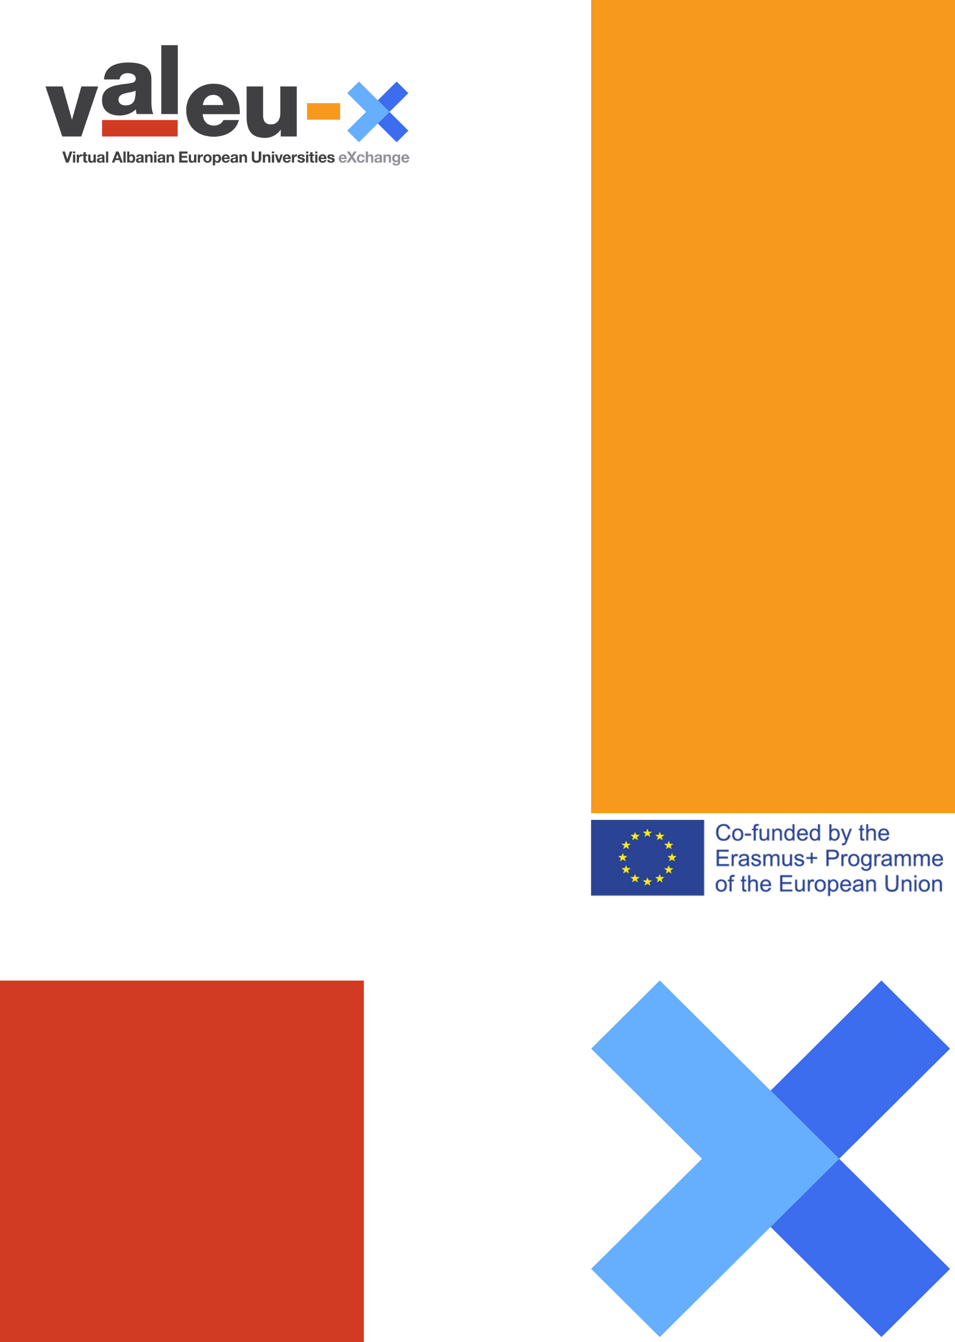

Cover Title

About VALEU-X
VALEU-X supports the internationalization of Albanian universities by introducing Virtual Blended Mobility as an internationalization at home instrument. VALEU-X is co-funded by the Erasmus+ programme of the European Union during the period January 2020-January 2022.

Members of the Consortium
- Technische Universitaet Dresden (TUD), Germany (coordinator)
- International School for Social and Business Studies (ISSBS), Slovenia
- Mediterranean Universities Union (UNIMED), Italy
- European University of Tirana (UET), Albania
- Epoka University (EPOKA), Albania
- University of Shkodra (USHK), Albania
- “FAN S. NOLI” University of Korka (UNIKO), Albania
- University of Elbasan (UNIEL), Albania
- Aleksander Moisiu University of Durres (AMU), Albania

More at
www.valeu-x.eu

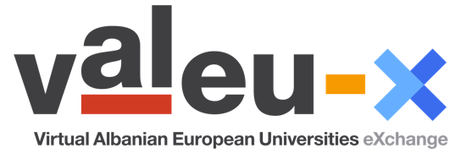

Document Information
Project Title | VALEU-X Virtual Albanian European Universities Exchange
Project n. | 610360-EPP-1-2019-1-DE-EPPKA2-CBHE-JP
Deliverable
Workpackage
Status | Version 1.0
Confidentiality Status | Restricted / Public
Author (Partner Institution)
Responsible Author(s)
Abstract (for dissemination)

Title
  - Subtitle

Heading 1

Heading 2

Heading 3
Lorem ipsum dolor sit amet, consectetur adipiscing elit, sed do eiusmod tempor incididunt ut labore et dolore magna aliqua. Ut enim ad minim veniam, quis nostrud exercitation ullamco laboris nisi ut aliquip ex ea commodo consequat. Duis aute irure dolor in reprehenderit in voluptate velit esse cillum dolore eu fugiat nulla pariatur. Excepteur sint occaecat cupidatat non proident, sunt in culpa qui officia deserunt mollit anim id est laborum.

